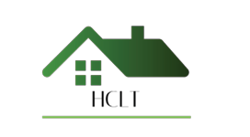
Haddenham Community Land Trust
Modern Slavery Statement

Haddenham Community Land Trust is committed to preventing modern slavery and human trafficking in all aspects of its work. We have a zero-tolerance approach to modern slavery and expect the same high standards from those who work with us, including contractors, consultants, and other suppliers.

We are committed to acting ethically, with integrity and transparency in all our activities. We seek to ensure that modern slavery, forced labour, human trafficking and exploitation have no place within our organisation or, so far as reasonably practicable, within our supply chains.

As a community-led organisation, we recognise our responsibilities under the Modern Slavery Act 2015 and are committed to complying with all relevant legal and regulatory requirements. We take a proportionate approach to assessing and managing the risk of modern slavery in our operations and procurement, including working with reputable partners and raising concerns where appropriate.

This statement applies to all trustees, employees, volunteers, and anyone acting on behalf of Haddenham Community Land Trust and will be reviewed on a regular basis.

Policy Review Record
Version Number | Status | Revision Date | Summary of Changes
Version 01 | New | June 2026 | New Policy

